**3. Managing VMs using Virt-Manager**

1. sudo virsh list

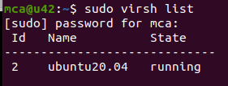

2. sudo virsh list –all

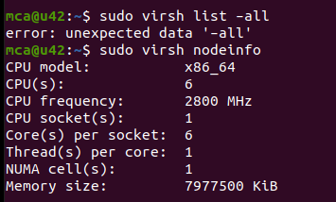

3. sudo virsh nodeinfo

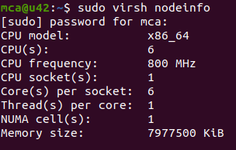

4. sudo virsh help list

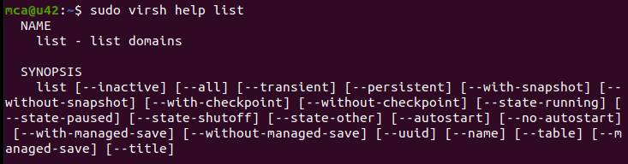

5. sudo virsh start <vmname>



6. sudo virsh reboot <vmname>



7. sudo virsh dominfo <vmname>

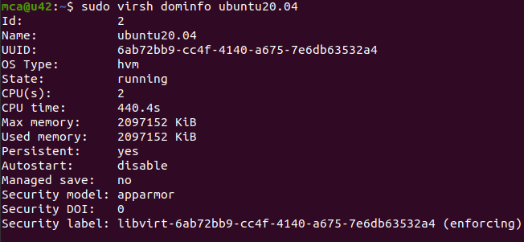

8. sudo virsh suspend <vmname>



9. sudo virsh resume <vmname>



10.sudo virsh shutdown <vmname>



11.sudo virsh save <vmname>

12.sudo virsh restore <vmname>

13.sudo virsh edit <vmname>

14.sudo virsh destroy <vmname>



15.sudo virsh undefine --domain <vmname> --remove-all-storage



